Project: AI-driven rare earth & critical mineral targeting for McEwen Mining using RareEarthMineralMapper

1) Executive summary
McEwen Mining has invested in field sensors, geophysical surveys, drill programs, and lab assays that collectively contain a “hidden map” of mineralization signals—often fragmented across teams, vendors, formats, and time. We propose a phase-based program to (1) rapidly understand what data exists and how it is currently used, (2) run a parallel industry + academic literature benchmark to define best-practice workflows, and (3) deliver a concrete, measurable path to improve mineral detection and drill targeting using our AI platform RareEarthMineralMapper.
The core outcome is a practical, deployable “Data Value Chain” for exploration at McEwen—turning raw/heterogeneous datasets into ranked targets, uncertainty-aware decision support, and a continuously improving workflow where new drill results feed back into model learning and future survey planning.

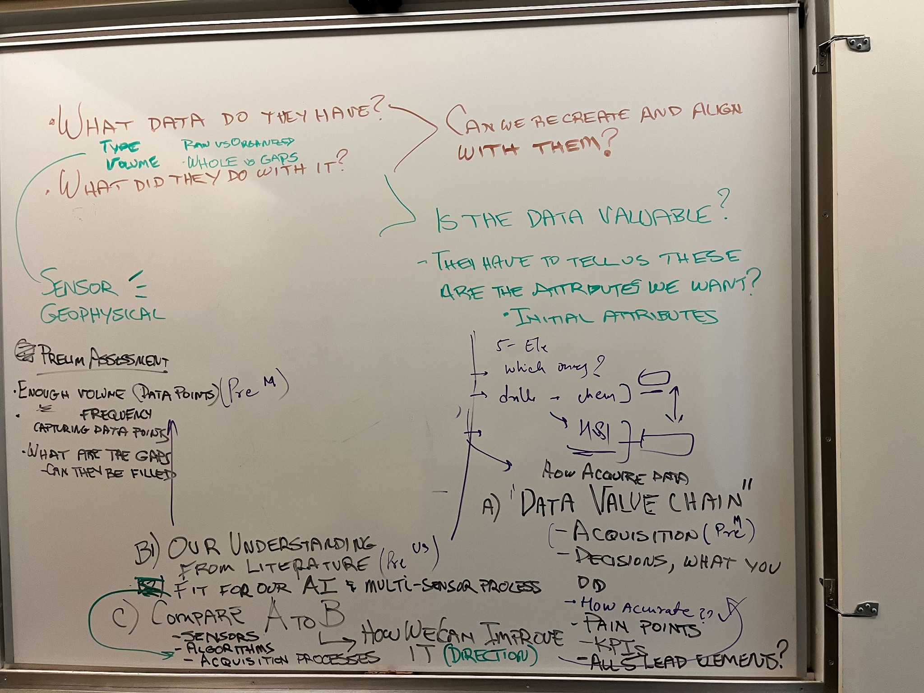

2) Why this work now
Exploration decisions are increasingly limited not by lack of data, but by:
- Data fragmentation: “raw vs organized,” incomplete coverage, and gaps in time/space.
- Under-utilized information: data exists but is not systematically translated into decisions.
- Sensor and method mismatch: the right sensors may exist, but acquisition, processing, and fusion are not optimized for the geological question.
- No closed-loop learning: drill outcomes often do not become structured “training points” that improve future targeting.
Our phased approach directly addresses these issues by starting with McEwen’s current reality (Phase 1), benchmarking what “good” looks like (Phase 2), and then providing an actionable improvement roadmap and pilot implementation (Phase 3+).

3) Project phases

Phase 1 — Data & sensor discovery (McEwen-specific)
Goal: Understand what data McEwen has, how it is collected, what has been done with it, and whether it is valuable for AI-driven targeting.

Phase 1 key questions (from your notes)
- What data do they have?
  - Type (geophysical / geochemical / geological / remote sensing / drilling / lab assays)
  - Volume (enough data points?) and frequency of data capture
  - “Raw vs organized,” completeness (holes vs gaps)
- What did they do with it?
  - Current interpretation workflows, tools, vendors
  - How the outputs influence decisions (or not)
- Can we recreate and align with them?
  - Reproducibility of current maps/targets
  - Alignment with McEwen teams and validation against historical outcomes
- Is the data valuable?
  - Does it contain the attributes we want?
  - Define “initial attributes” required for modeling (examples below)

Phase 1 activities
A. Sensor + dataset inventory (2–4 weeks)
- Catalog sensors and acquisition specs (e.g., geophysical modality, survey parameters, spatial resolution, sampling design).
- Inventory data sources and formats: grids, point samples, drill logs, assay tables, shapefiles, vendor reports, imagery, etc.
- Map data ownership & access rules (internal teams, vendors, labs).
B. Preliminary assessment (quality & feasibility)
- Volume: enough data points to learn meaningful patterns.
- Frequency: how often data is collected/updated; what is “current.”
- Gaps: identify missing areas/intervals; assess whether gaps can be filled (new surveys, targeted sampling, remote sensing backfill).
C. Define “initial attributes” and target variables
We will agree with McEwen on:
- Target outcomes: what constitutes success (e.g., ore zone probability, REE grade threshold, pathfinder signals).
- Training points: drill intersections + assays, geochem samples, confirmed lithology/alteration zones.
- Attributes/features: multi-sensor predictors (geophysics, geology, structure, remote sensing indices, geochem pathfinders).
- Accuracy requirements: acceptable uncertainty, false positives/negatives tradeoffs.
D. Build McEwen’s “Data Value Chain” map
A clear map from:
- Acquisition → Processing → Interpretation → Decision → Outcome
including:
- What decisions are made today, by whom, with what information
- Where uncertainty exists
- Where time/cost is spent
- Where “conversion” from data to action breaks down

Phase 1 deliverables
- Data & Sensor Register (what exists, where it lives, formats, coverage)
- Data Quality Report (volume, frequency, gaps, usability)
- McEwen Data Value Chain (how data becomes decisions today)
- Reproducibility check (can we recreate existing interpretations/targets)
- Phase 3 pilot recommendation shortlist (which area + which datasets are best suited)

Phase 2 — Literature & benchmark survey (in parallel with Phase 1)
Goal: Establish the best-known approaches in industry + academia for mineral targeting using multi-sensor data and modern AI, and translate them into a practical workflow suitable for McEwen.

Phase 2 activities (parallel track)
A. Research + industry survey
- Multi-sensor fusion for exploration: geophysics + geochemistry + geology + remote sensing + drilling
- Target generation methods: supervised learning, semi-supervised, anomaly detection, probabilistic modeling
- Uncertainty estimation and decision support for drilling
- Best practices in data management: reproducible pipelines, QA/QC, audit trails
B. “Fit for our AI + multi-sensor process”
- Identify which methods truly work with real-world constraints (sparse drill data, biased sampling, inconsistent surveys).
- Define minimal viable requirements and scalable architecture.

Phase 2 deliverables
- Benchmark report (what works, when, and data requirements)
- Reference workflow (recommended sensors + algorithms + acquisition patterns)
- KPI framework (how to measure improvements objectively)

Phase 3 — Compare A vs B and propose improvements (the core proposal to McEwen)
Goal: Compare McEwen’s current value chain (Phase 1 “A”) to best-practice workflows (Phase 2 “B”), then propose a phased modernization plan with RareEarthMineralMapper.

What we will compare (from your notes)
- Sensors (what McEwen has vs what’s optimal)
- Algorithms (current interpretation vs AI/physics-informed methods)
- Acquisition processes (how data is collected vs what would reduce uncertainty fastest)

Proposed improvements using RareEarthMineralMapper
RareEarthMineralMapper is designed to transform exploration into a closed-loop, multi-sensor AI targeting system:
1) Unified multi-sensor data layer (“single source of truth”)
- Standardize and align disparate datasets (geophysics, assays, drill logs, imagery, geology) into a consistent spatial framework.
- Track metadata, QA/QC, and provenance so outputs are auditable.
2) Target probability maps (not just maps—probabilities + uncertainty)
- Produce ranked target zones with confidence intervals.
- Explicitly quantify uncertainty to guide where additional data would be most valuable.
3) Active learning: drill results become training points
- Every new drill hole and assay becomes a structured learning signal.
- The system improves over time, rather than restarting interpretation each season.
4) Decision support tied to KPIs
We propose KPIs such as:
- Improved hit rate (mineralized intercepts per meters drilled)
- Reduced cost per discovery-relevant target
- Reduced time from acquisition to target ranking
- Better ranking stability under uncertainty
- “Value-of-information” score for next survey / next drill planning

Phase 3 deliverables
- Gap analysis (“How we can improve it”) with prioritized recommendations
- Pilot design: area selection, datasets, success metrics, timeline
- Prototype outputs (depending on data access): initial target ranking maps, uncertainty maps, and recommended next actions

Phase 4 — Pilot implementation and scale-up (recommended)
Pilot objective: Demonstrate measurable improvement on one asset/area before scaling enterprise-wide.

Phase 4 activities
- Build production-grade ingestion + processing pipeline (repeatable, versioned)
- Train initial RareEarthMineralMapper models on historical drilling + surveys
- Validate against held-out outcomes (historical holes, known zones)
- Deliver target ranking + drill planning recommendations
- Operationalize: dashboards + GIS exports + audit logs + training for McEwen teams

Scale-up
- Expand to additional deposits/regions
- Add new sensors or optimize acquisition plans guided by model uncertainty
- Establish ongoing monthly/quarterly update cycles

4) What we need from McEwen (initial)
To start Phase 1 efficiently, we request:
- Point of contact for exploration geology + geophysics + drilling data
- Sample datasets (or secure access) for:
  - Geophysical survey products (grids, line data if available)
  - Drill collar + survey + lithology logs + assays
  - Surface geochemistry samples (if any)
  - Geological maps/interpretations and any historical target maps
- A short walkthrough of: “What decisions do you make today from this data?”

5) Suggested timeline (first draft)
- Weeks 1–4: Phase 1 data/sensor discovery + preliminary assessment
- Weeks 1–4 (parallel): Phase 2 literature + benchmark report
- Weeks 5–6: Phase 3 comparison + improvement roadmap + pilot design
- Weeks 7–12 (optional pilot): Phase 4 pilot build + validation + deliverables
(We can compress/expand based on data readiness and internal bandwidth.)

6) Commercial & governance (first draft placeholders)
- Data confidentiality: All McEwen data remains McEwen property; EyeClimate operates under NDA and secure handling procedures.
- Deliverable ownership: McEwen receives full outputs for internal decision-making; model artifacts and code licensing can be structured as pilot → subscription → enterprise deployment.
- Integration: Outputs delivered as GIS-ready layers, reports, and optional web dashboard.

7) Next step (recommended)
A 60–90 minute technical working session with McEwen to:
- confirm priority asset/area,
- confirm sensor list and data availability,
- define the “initial attributes” and success KPIs, and
- finalize Phase 1 scope and timeline.

